**Student name: Trevor Cardoza SMC username: tmc12**

Instructions: Fill out your full name and SMC username above. Answer each question in its respective following space. **Give a sufficient yet succinct answer for each question and show results / figures / tables / graphs on this same sheet when appropriate or explicitly requested.** After completion, rename and save this file as **“Assignment 1_BUSAD 137_*your full name*” in either MS Word (.docx or .doc) or PDF (.pdf) format** then upload and submit it **together with the completed Excel files** on Moodle by the due date. No other file formats will be accepted. A late or email submission will NOT be accepted.

**Total possible points: 90**

1. **Non-linear regression model (30 points in total)**

A sample containing years to maturity and yield (percent) for 40 corporate bonds are contained in the provided Excel data file named ***CorporateBonds*** (Barron’s, April 2, 2012).

1.1 Develop and show a scatter chart of the data using years to maturity as the independent variable. Does a simple linear regression model appear to be appropriate? (5 points)

**Yes because it shows us a clear separation between the yield between 10 years and 25 years**

1.2 Develop and show an estimated quadratic regression equation with years to maturity and squared values of years to maturity as the independent variables. How much variation in the sample values of yield does this regression model explain? Is the overall regression relationship significant at a 0.05 level of significance? If so, then test the relationship between each of the independent variables and the dependent variable at a 0.05 level of significance. How would you interpret this model? How does the yield change when years to maturity increases by 1 year from some value x to x+1? At approximately how many years does the estimated maximum yield occur? And what is the estimated maximum yield at that point in time? (15 points)

1.3 Create a plot of the linear and quadratic regression lines overlaid on the scatter chart

of years to maturity and yield. Does this help you better understand the difference in how the quadratic regression model and a simple linear regression model fit the sample data? Which model does this chart suggest provides a superior fit to the sample data? Also run the baseline model (i.e., the simple linear regression model) in Excel and compare the coefficients of determination (R2) of this baseline model and the earlier quadratic model, whose R2 value is larger? (10 points)

**Baseline: 0.526750659**

**Quadratic: 0.380024613**

**Baseline is bigger**

**I believe the simple linear regression fits this data better**

1. **Linear Optimization Model (60 points in total)**

Kelson Sporting Equipment, Inc., makes two types of baseball gloves: a regular model and a catcher’s model. The firm has 900 hours of production time available in its cutting and sewing department, 300 hours available in its finishing department, and 100 hours available in its packaging and shipping department. The production time requirements and the profit contribution per glove are given in the following table:

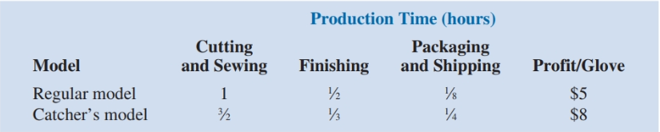

Assuming that the company is interested in **maximizing the total profit contribution**, answer the following questions.

2.1 What is the linear programming model for this problem expressed in the mathematical form? Write down the entire mathematical model in the following space including the explicit and implicit constraint inequalities. Let R = number of units of regular model, and C = number of units of catcher’s model. (15 points)

2.2 Develop a spreadsheet model by completing the missing parts indicated by the bordered cells **except the two shaded cells** in the provided ***Kelson.xlsx*** file and find the optimal solution using Excel Solver. Generate an **answer report** on a separate worksheet in the same Excel file. According to the optimal model result or the answer report, how many of each glove model should Kelson manufacture to achieve the optimal solution? (25 points)

**500 Regular**

**150 Catchers**

2.3 What is the total profit contribution Kelson can earn with the optimal production quantities? How many hours of production time will be scheduled in each department? (5 points)

**$3,700 of total profit**

2.4 According to the answer report, among the three explicit constraints (Hours Available for Cutting and Sewing, Hours Available for Finishing, and Hours Available for Packaging and Shipping), which constrain(s) are binding? What is the slack time in each department? (5 points)

2.5 Generate a **sensitivity report** this time on a separate worksheet in the same Excel file. What are the three explicit constraints’ shadow prices according to the sensitivity report. What does each shadow price mean for each corresponding constraint? (10 points)